FINAL PROJECT REPORT
Project Title:
High Availability Router Project using HSRP and GNS3.
Course:
Computer Networks Lab
Submitted To:
Sir Muhammad Fahad Irshad
Submitted By: (Group 6)
- Sumaiya Bibi F2024266340
- Rameen Junaid F2024266341
- Tayyba Shahzad F2024266348
- Eshmal Zahid F2024266755
Introduction:
This project implements a High Availability Network using HSRP (Hot Standby Router Protocol). The purpose of the project is to provide gateway redundancy and ensure continuous network connectivity in case of router failure.
Objectives:
• Implement HSRP for gateway redundancy.
• Configure secure remote access using SSH.
• Apply ACL-based security controls.
• Perform failover and recovery testing.
• Verify network connectivity and performance.

Network Topology:
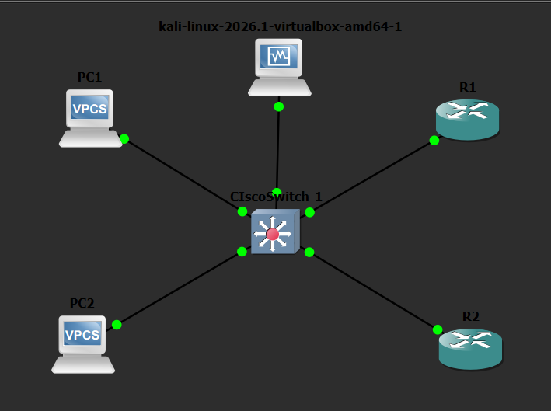
The network consists of two routers, one switch, end devices, and a Kali Linux machine used for security testing. RouterA acts as the Active router while RouterB acts as the Standby router.

IP Addressing Plan:
RouterA: 192.168.1.1
RouterB: 192.168.1.2
Virtual IP: 192.168.1.254
PC1: 192.168.1.10
PC2: 192.168.1.11
Kali Linux: 192.168.1.100
HSRP Configuration:
HSRP was configured to provide gateway redundancy. RouterA was assigned a higher priority and operated as the Active router. RouterB remained in Standby mode and automatically became Active during failover testing.

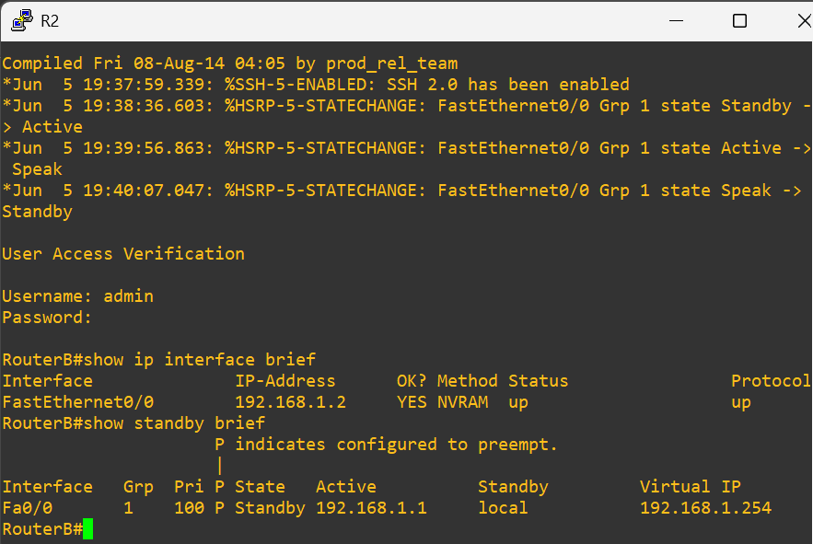
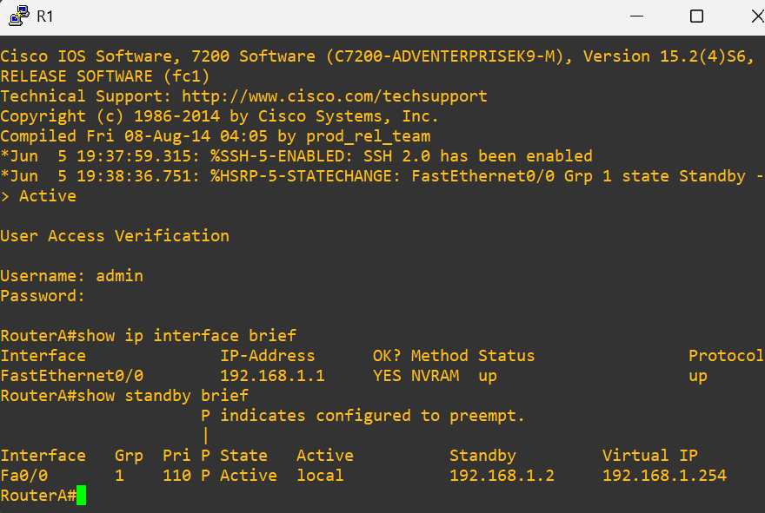

Security Implementation:
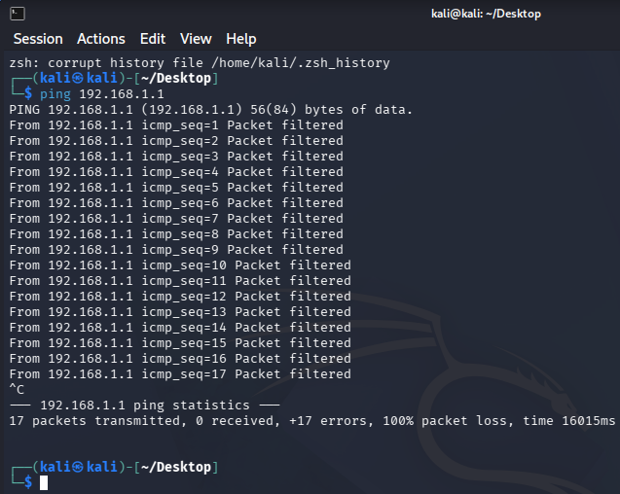
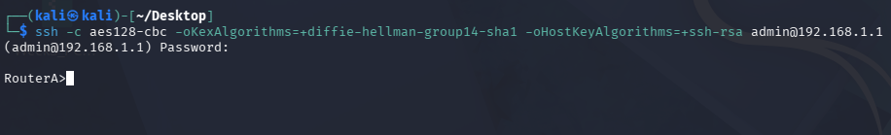
SSH was configured for secure remote management.

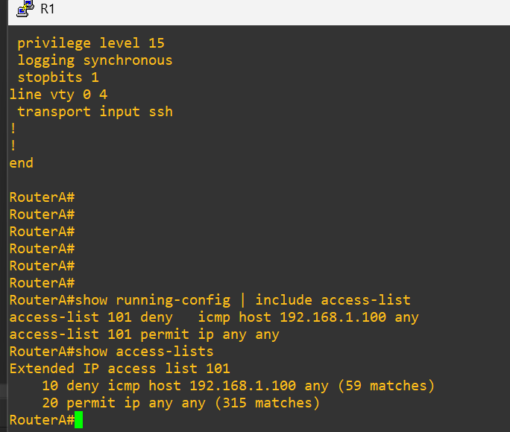
ACL rules were implemented to filter unauthorized traffic and improve network security.

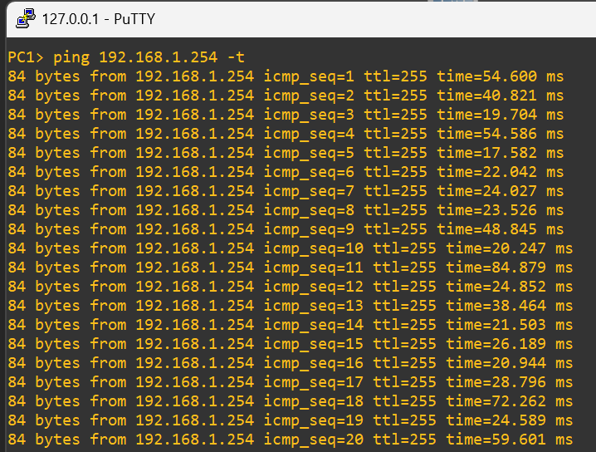

Testing and Verification:
Connectivity tests between PCs and the Virtual IP were successful.
Failover testing confirmed automatic transition from RouterA to RouterB.
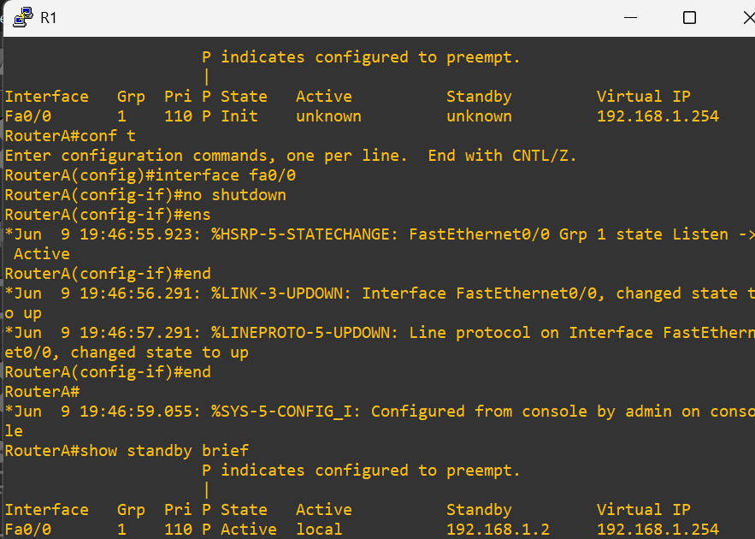
Recovery testing confirmed automatic restoration of RouterA as the Active router.

Performance Results:
Average latency remained approximately 35 ms during testing.
Network throughput remained stable during failover testing.
Conclusion:
The project successfully implemented a high availability network using HSRP. Security mechanisms and failover functionality operated as expected.

